The Lions Foundation of Canada Dog Guides needs your support; will you purchase a puppy calendar today?
$20 cash or e-transfer to myemail@address.com
Donate Directly to  Dog Guides!  Dogguides.com/Donate | 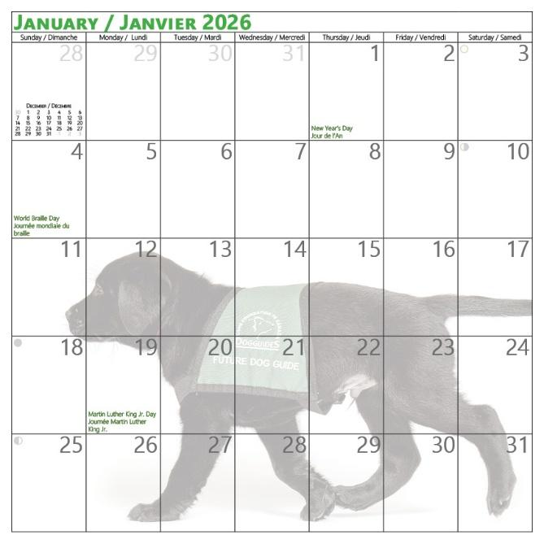  Filled with adorable puppy photos and enough space to write in your important notes and appointments.

