Don’t ring the doorbell unless you are prepared to purchase a Green Capes Dog Guide Puppy Calendar!

$20 cash or e-transfer to myemail@address.com
Donate Directly to  Dog Guides!  Dogguides.com/Donate | 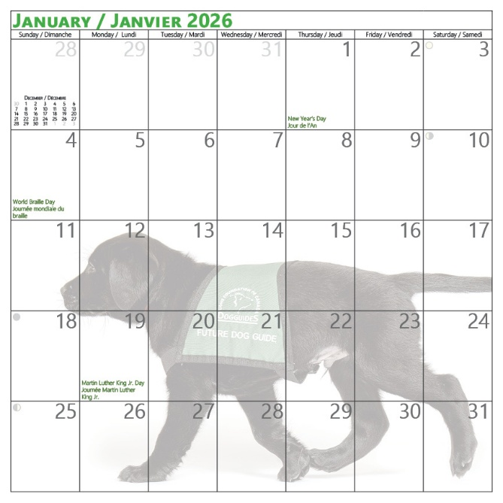  Filled with adorable puppy photos and enough space to write in your important notes and appointments.

